Planning Document

Joel Hilley 92060012

School Subject Database/WebApp Project

**Iteration 1: 3/12/20**

* Develop Team Contract
* Create Github Project / Repository
* Solution Design Document

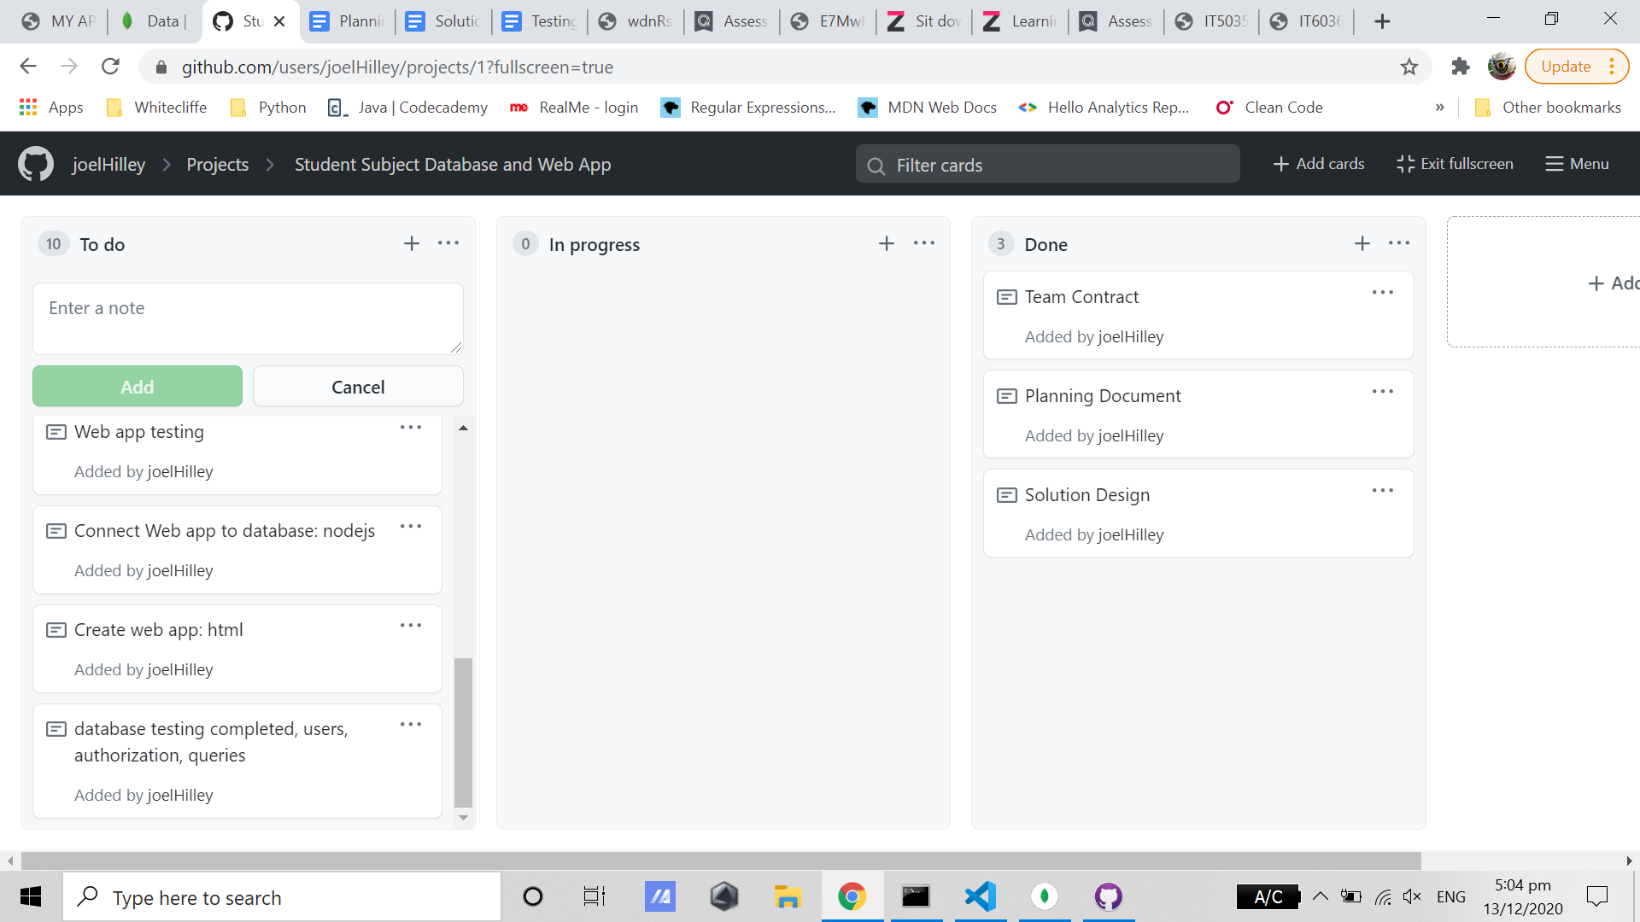

**Iteration 2: 7/12/20**

* Database Development
  + Data imported
  + Users created
    - Authentication
    - Authorization
* Create Queries
* Testing Document
  + Test access control features
  + Test queries

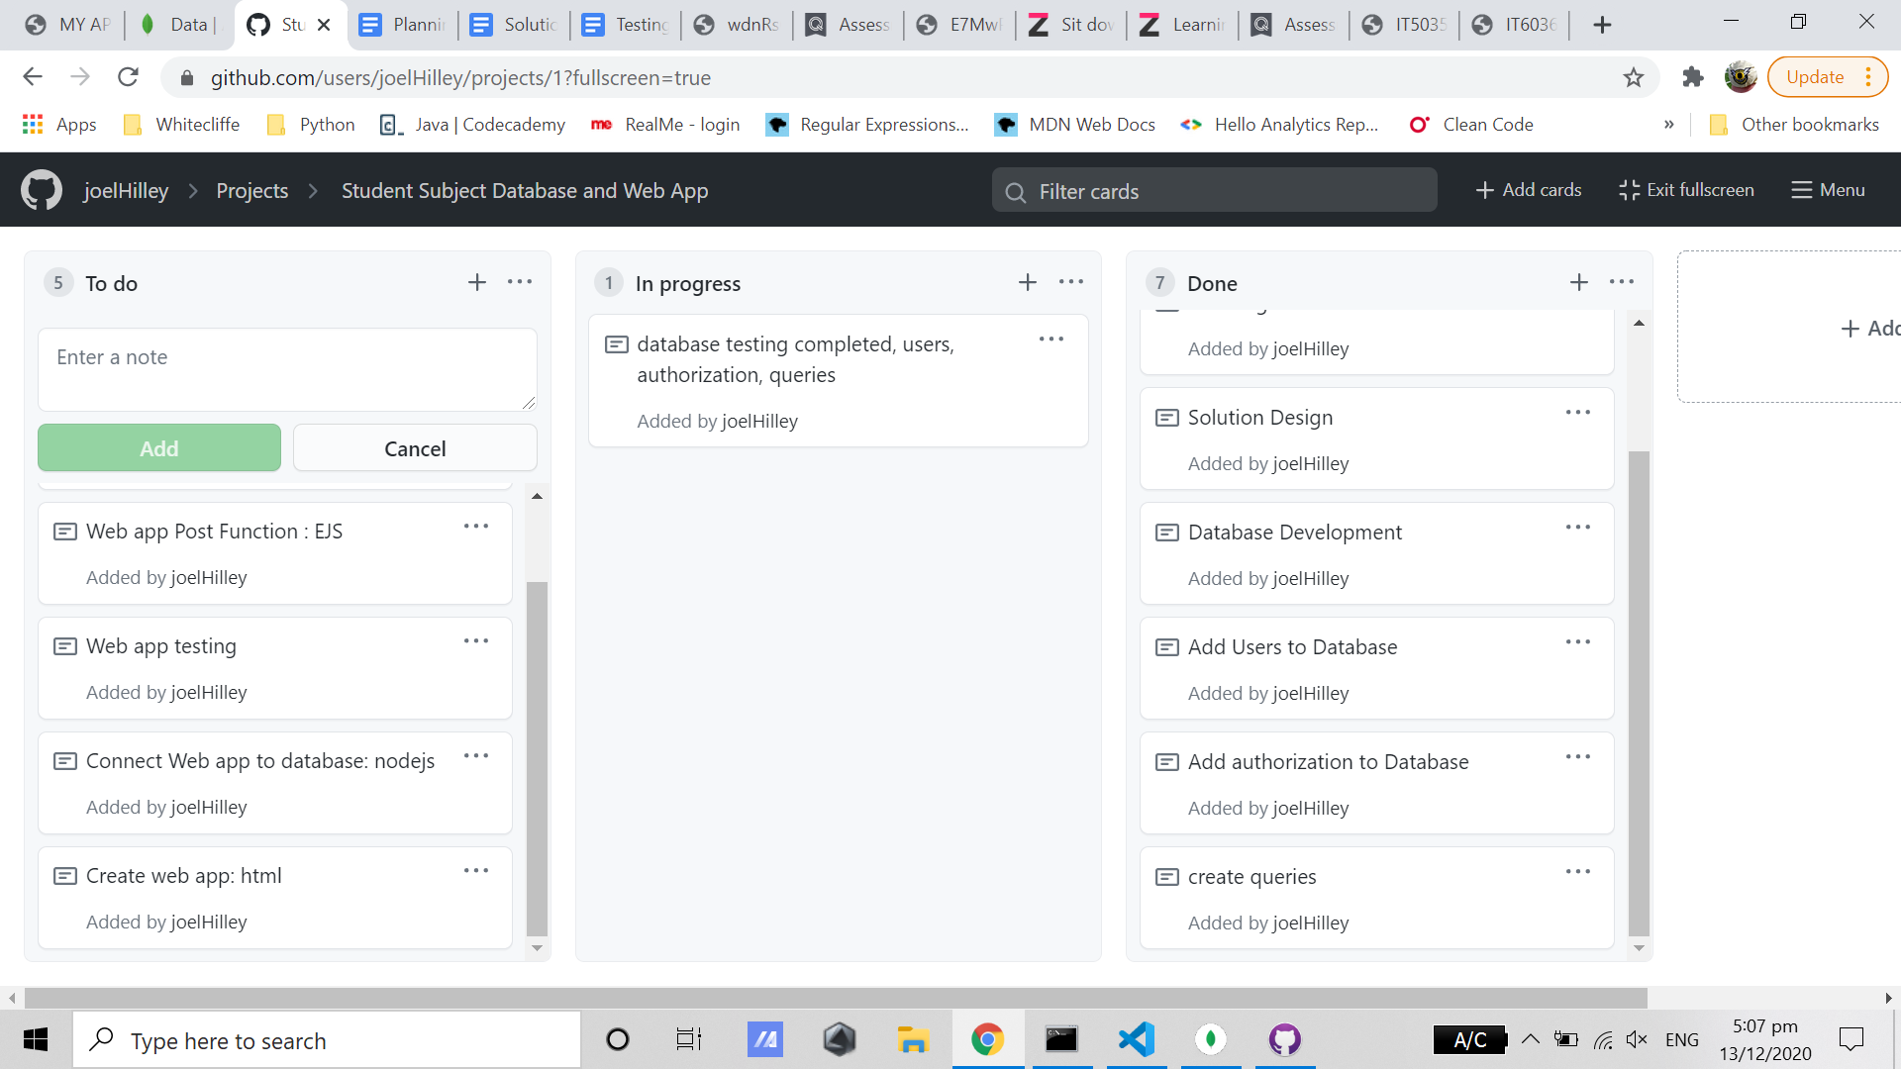

**Iteration 3 (MVP): 12/12/20**

* Web App Development
* Connect Web App with MongoDB Atlas cluster
* ‘POST’ functionality of web app. Submit data to database via web app.

**Iteration 4 (Stretch Goal): 12/12/20**

* User login
* ‘Put’ and ‘Delete’ requests

